ONEWAY PREC BY FPS
/STATISTICS DESCRIPTIVES HOMOGENEITY WELCH
/PLOT MEANS
/MISSING ANALYSIS.

Oneway

Notes
Output Created |  | 05-May-2019 23:58:24
Comments
Input | Active Dataset | DataSet0
Input | Filter | <none>
Input | Weight | <none>
Input | Split File | <none>
Input | N of Rows in Working Data File | 30
Missing Value Handling | Definition of Missing | User-defined missing values are treated as missing.
Missing Value Handling | Cases Used | Statistics for each analysis are based on cases with no missing data for any variable in the analysis.
Syntax |  | ONEWAY PREC BY FPS  /STATISTICS DESCRIPTIVES HOMOGENEITY WELCH  /PLOT MEANS  /MISSING ANALYSIS.
Resources | Processor Time | 00 00:00:00.156
Resources | Elapsed Time | 00 00:00:00.165

[DataSet0]

Descriptives
 | N | Mean | Std. Deviation | Std. Error | 95% Confidence Interval for Mean
 |  |  |  |  | Lower Bound | Upper Bound
30 FPS | 13 | 32.6923 | 36.37853 | 10.08959 | 10.7090 | 54.6756
60 FPS | 17 | 53.5294 | 34.81041 | 8.44276 | 35.6316 | 71.4273
Total | 30 | 44.5000 | 36.42067 | 6.64947 | 30.9003 | 58.0997

Descriptives
 | Minimum | Maximum
30 FPS | .00 | 120.00
60 FPS | 5.00 | 130.00
Total | .00 | 130.00

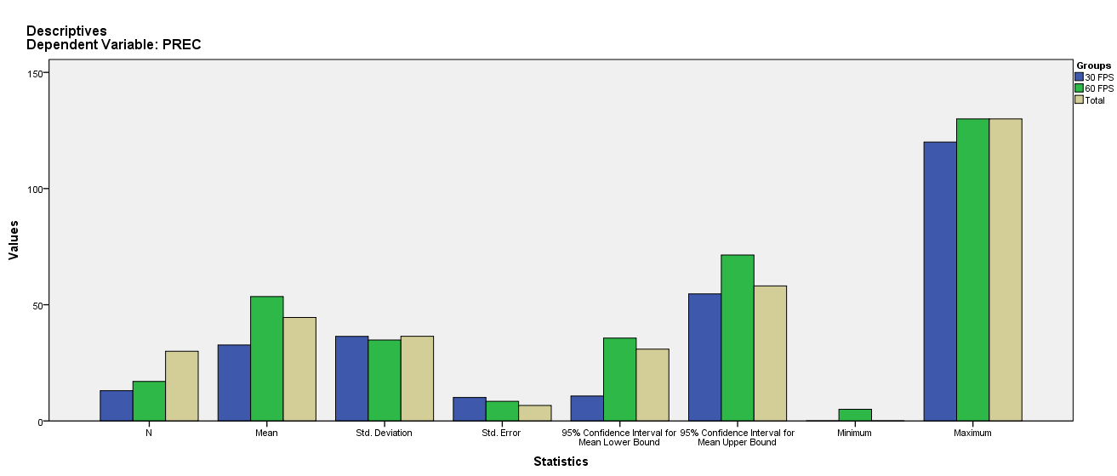

Test of Homogeneity of Variances
PREC
Levene Statistic | df1 | df2 | Sig.
.107 | 1 | 28 | .746

ANOVA
PREC
 | Sum of Squares | df | Mean Square | F | Sig.
Between Groups | 3198.495 | 1 | 3198.495 | 2.539 | .122
Within Groups | 35269.005 | 28 | 1259.607
Total | 38467.500 | 29

Robust Tests of Equality of Means
PREC
 | Statisticª | df1 | df2 | Sig.
Welch | 2.509 | 1 | 25.362 | .126
a. Asymptotically F distributed.

Means Plots

